YOUR DAY IS MY NIGHT
你的白天是我的黑夜

a film by Lynne Sachs

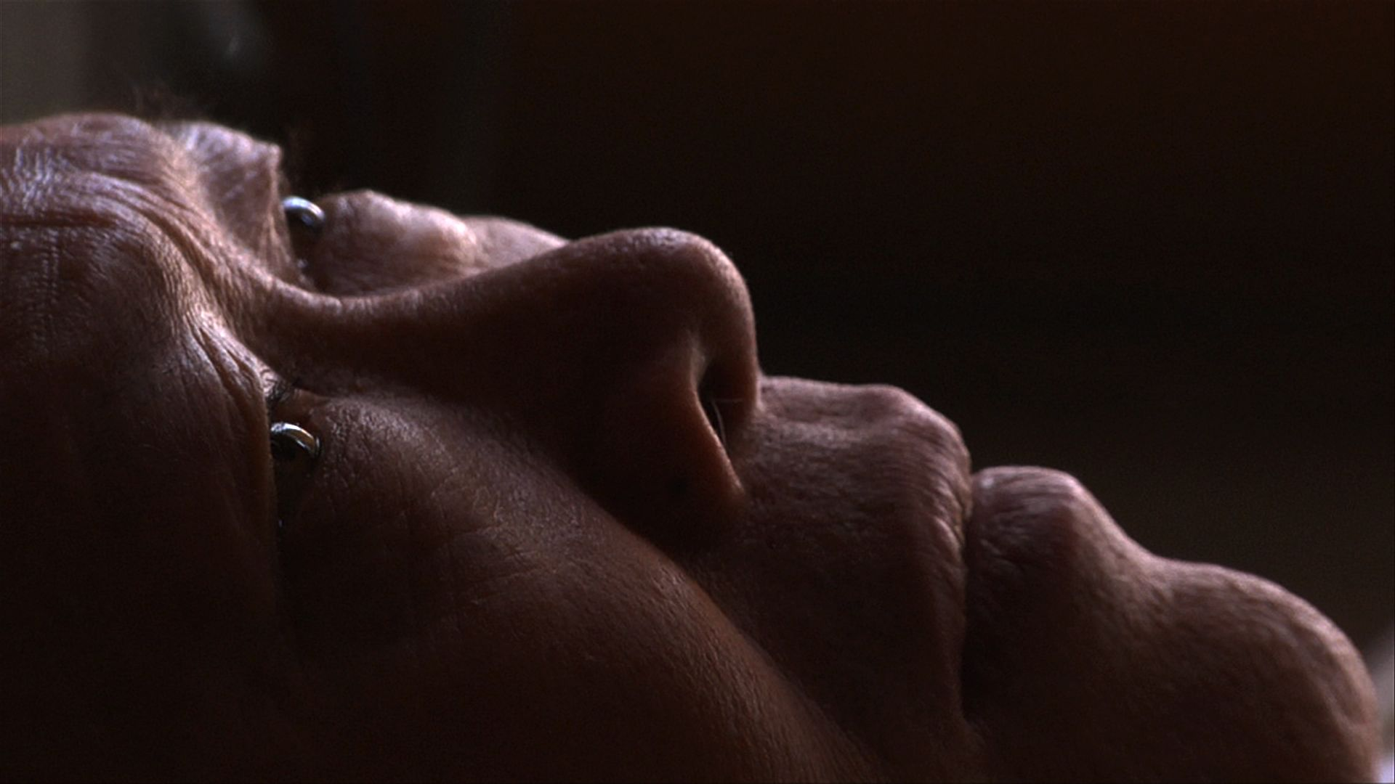

65 min., HD, Color, Stereo & 5.1 Surround, 2013
Chinese, English & Spanish with English Subtitles

While living in a “shift-bed” apartment in the heart of New York City’s Chinatown,
a household of immigrants shares their stories of personal and political upheaval.

Select Screenings:
World Premiere: Museum of Modern Art, Documentary Fortnight 2013
Vancouver International Film Festival, Vancouver BC, Canada
Ann Arbor Film Festival, Ann Arbor MI
Images Festival, Toronto ON, Canada
San Diego Asian Film Festival (Winner: Best Documentary Feature)
Traverse City Film Festival (Winner: Best Experimental Feature)

“One of the most mysterious and magical evocations of the migrant city in many a year.”
- Sukhdev Sandhu, Sight & Sound

“Your Day is My Night is a strikingly handsome, meditative work: a mixture of reportage, dreams, memories and playacting, which immerses you in an entire world that you might unknowingly pass on the corner of Hester Street.”
- Stuart Klawans, The Nation

Contact:  Lynne Sachs, director and producer  lynnesachs@gmail.com  www.lynnesachs.com  718.522.5856  917.292.5856 | Jim Browne, Argot Pictures  jim@argotpictures.com  www.argotpictures.com

Synopsis:
Since the early days of New York's Lower East Side tenement houses, working class people have shared beds, making such spaces a fundamental part of immigrant life. Initially documented in Jacob Riis’ now controversial late 19th Century photography, a “shift-bed” is an actual bed that is shared by people who are neither in the same family nor in a relationship. Simply put, it’s an economic necessity brought on by the challenges of urban existence. Such a bed can become a remarkable catalyst for storytelling as absolute strangers become de facto confidants.
In this provocative, hybrid documentary, the audience joins a present-day household of immigrants living together in a shift-bed apartment in the heart of Chinatown. Seven characters (ages 58-78) play themselves through autobiographical monologues, verité conversations, and theatrical movement pieces. Retired seamstresses Ellen Ho and Sheut Hing Lee recount growing up in China during the turmoil of the 1950s when their families faced violence and separation under Chairman Mao’s revolutionary, yet authoritarian regime. Yun Xiu Huang, a nightclub owner from Fujian Province, reveals his journey to the United States through the complicated economy of the “snakehead” system, facing an uphill battle as he starts over in a new city.
With each “performance” of their present, the characters illuminate both the joys and tragedies of their past. As the bed transforms into a stage, the film reveals the collective history of Chinese immigrants in the United States, a story not often documented. Further, the intimate cinematography and immersive sound design carry us into the dreams and memories of the performers, bringing the audience into a community often considered closed off to non-Chinese speakers. Through it all, “Your Day is My Night” addresses issues of privacy, intimacy, and urban life in relationship to this familiar item of household furniture.

Short Description:
While living in a “shift-bed” apartment in the heart of New York City’s Chinatown, a household of immigrants shares their stories of personal and political upheaval. As the bed transforms into a stage, the film reveals the collective history of the Chinese in the United States through conversations, autobiographical monologues and theatrical movement pieces. Shot in the kitchens, bedrooms, wedding halls, cafés and mahjong parlors of Chinatown, this provocative, hybrid documentary addresses issues of privacy, intimacy, and urban life.

Director’s Statement:
“I’ve spent most of my life as an artist thinking about how to convey my observations of the world around me in the visual and aural language of film. I experiment with my perception of reality by embracing an associative, non-literal approach to images, and it is through this artistic exploration that I grapple with the natural, social, cultural and political phenomena that I witness through the lens of my camera. I began the Your Day is My Night project in late 2009 when I was talking with a relative on his 90th birthday. A Brooklyn resident for his entire life, Uncle Bob has haunting memories of December 16, 1960 when a jet crashed near his Brooklyn home. Trying to imagine the devastation in this busy neighborhood, I asked him how many people on the ground had died. ‘It was hard to know because there were so many hot bed houses in that area. They all burned and no one knew precisely who lived there.’ What are hot bed houses? I asked him. ‘Those are homes for poor people who work and can’t afford to rent their own apartments. They share beds in shifts.’ I reconstructed the moment of the crash, creating a mental image of the inhabitants of these apartments as they tried to gather their few personal possessions and escape the fire. Which unlucky person would awake from a deep sleep after a long shift at the port to the sound of the crash and the heat of the fire? After that conversation, I discovered that 19th Century photographer Jacob Riis documented numerous examples of these beds, and it is through his lens that I was able to begin my research. In Riis’ How the Other Half Lives, he exposed to the rest of America the poor, immigrant experience he witnessed in downtown New York City. I later read The Snakehead: An Epic Tale of the Chinatown Underworld and the American Dream by Patrick Radden Keefe to give me a more current sense of the situation in current day Chinatown.
I think of the bed as an extension of the earth. For most of us, we sleep on the same mattress every night; our beds take on the shape of our bodies, like a fossil where we leave our mark for posterity. During the Revolutionary War, George Washington slept in many borrowed beds and now, hundreds of years later, his brief presence is celebrated from one New England town to the next: ‘George Washington Slept Here’ has a kind of strange signification and prestige. But for transients, people who use hotels, and the homeless a bed is no more than a borrowed place to sleep. An animal that borrows its home from another species is called an inquiline, and in Spanish inquilina is the word for a renter. Conceptual artist and sculptor Félix González-Torres photographed a series of empty, unmade beds to commemorate the life and death of his partner, as if the very sheets that remained could remind him and us of the body and the man he had loved.
Since January of 2011, I have been writing, researching, and shooting material for my ‘bed project’ in the Chinatown neighborhood of New York City. I found a group of non-professional Chinese performer/participants (ages 58 – 78) and have worked almost weekly with them ever since. During our workshops, they each exchanged their own stories around domestic life, immigration and personal-political upheaval. None of these people has ever worked in this cross-cultural way, so it is these taped process-oriented conversations that, in the final film, enhance our audience’s sense of the bed - experienced and imagined from profoundly different viewpoints. Next, a written script emerged from our months of shooting documentary images and interviews. Using the interactive model of Augusto Boal’s “Theatre of the Oppressed”, I guided my collective in a “simultaneous dramaturgy”. My performers, crew and, more recently, our live audience, explored the potential for transformation that can come from a dialogue around personal histories and the imagination.
The material I collected during these interviews is the basis for the monologues in Your Day is My Night. In production, I guided my performers through visual scenarios that reveal a bed as a stage on which people manifest who they are at home and who they are in the world. Our shooting took place in two different actual shift-bed apartments located in NYC’s Chinatown. The Chinese participants (several of whom currently live or have actually slept on shift-beds) spoke of family ruptures during the Chinese Cultural Revolution, a mattress excavated from a garbage heap, four men on one bed in Chinatown, amongst a long series of fascinating and haunting bed-related topics.
“Your Day is My Night” has been exhibited as a live performance at St. Nicks Alliance in Greenpoint, Brooklyn, New York Public Library in Chinatown, Proteus Gowanus Interdisciplinary Arts Gallery in Brooklyn and University Settlement in Manhattan.” - LS

Director’s Biography:
Lynne Sachs makes films, videos, installations and web projects that explore the intricate relationship between personal observations and broader historical experiences by weaving together poetry, collage, painting, politics and layered sound design. Since 1994, her five essay films have taken her to Vietnam, Bosnia, Israel and Germany — sites affected by international war–where she tries to work in the space between a community’s collective memory and her own subjective perceptions. Strongly committed to a dialogue between cinematic theory and practice, Lynne searches for a rigorous play between image and sound, pushing the visual and aural textures in her work with each and every new project. Since 2006, she has collaborated with her partner Mark Street in a series of playful, mixed-media performance collaborations they call The XY Chromosome Project. In addition to her work with the moving image, Lynne co-edited the 2009 Millennium Film Journal issue on “Experiments in Documentary”. Supported by fellowships from the Rockefeller and Jerome Foundations and the New York State Council on the Arts, Lynne’s films have screened at the Museum of Modern Art, the New York Film Festival, Sundance Film Festival and in a five film survey at the Buenos Aires International Film Festival. The San Francisco Cinematheque recently published a monograph with four original essays in conjunction with a full retrospective of Lynne’s work. Lynne teaches experimental film and video at New York University and lives in Brooklyn. For more info: www.lynnesachs.com

Aesthetic Influences:
In 1986, I saw French film essayist Chris Marker's "Sans Soleil". Soon after, I wrote Marker a fan letter along with a personal interpretation of the film to which he surprisingly responded. We soon met, marking the beginning of a twenty-five-year friendship that pushed me to think about cinema more radically and personally and lasted until his death in 2012. Both of us use cinematic fragments to document the complexities of real people’s lives. Later, Chinese director Jia Zhangke’s mixing of documentary and fiction became a critical point of departure for this project in terms of his articulation of the personal stories of his performers.
In Paris and NYC, I have witnessed the austere yet playful dramaturgy of Ariane Mnouchkine’s Theatre du Soleil. I was captivated by her ability to convey acute perception through discrete visual scenarios. Mnouchkine’s production process inspired the one I use in “Your Day is My Night”. She works closely over a long period with a collective of trained and untrained actors to create a work that does not “shape life into taut dramatic form but presents lived experience intimately.”

Credits:

Featuring: Yi Chun Cao, Linda Y.H. Chan, Chung Qing Che, Ellen Ho, Yun Xiu Huang, Sheut Hing Lee, & Kam Yin Tsui, Veraalba Santa
Director, Producer: Lynne Sachs
Co-producer, Cinematographer, Editor: Sean Hanley
Original Music & Additional Sound Design: Stephen Vitiello
Cinematographer: Ethan Mass
Writing: Rojo Robles, Lynne Sachs
Translations and Production Managing: Catherine Ng, Jenifer Lee
Sound Recording: Amanda Katz, Jeff Sisson
Sound Mix: Damian Volpe
Additional Editing and Translating: Bryan Chang

Selected Biographies and Anecdotes:

Stephen Vitiello, internationally known avant-garde sound artist, on the original music and sound design:

“I approached the soundtrack to Lynne's film with a fairly limited palette - prepared piano, plus a simple synthesizer and source recordings that came from the film shoots (which I was not part of) as well as my own archive of field recordings. 2012 was John Cage's centennial, so there's been a good deal of prepared piano in the air. In this case, I went back to recordings I had made during a residency in 2011, where I had daily access to a piano and no one seemed to mind (or know) that I was sticking forks, knives and leaves between the instrument's strings. While working on Your Day is My Night, I manipulated those piano performances as I watched or remembered various scenes. I tried to absorb the different spaces of the film and create one feel for the apartment sequences and another for the staged performances. I'd like to think that (at least subliminally), you'll hear the rhythms of soft padding feet and sleep-filled breathing somewhere in the bed of sounds.” - SV

Bio:
Stephen Vitiello is an electronic musician and media artist. Vitiello’s sound installations have been presented internationally, including MASS MoCA; the 2002 Whitney Biennial, the 2006 Biennial of Sydney, at the Cartier Foundation, Paris and a site-specific project on the High Line in NYC. CD releases include Bright and Dusty Things (New Albion Records); Listening to Donald Judd (Sub Rosa); The Gorilla Variations (12k); and Box Music (12k). Since 1989, Vitiello has collaborated with numerous artists and musicians including Pauline Oliveros, Tony Oursler, Julie Mehretu, Scanner, Steve Roden, Taylor Deupree and Ryuichi Sakamoto. In 2011, ABC-TV, Australia produced the documentary Stephen Vitiello: Listening With Intent. Originally from New York, Stephen is now based in Richmond, VA where he is on the faculty of the Kinetic Imaging Department at Virginia Commonwealth University. More at: www.stephenvitiello.com

Sean Hanley, cinematographer, on the film’s imagery:
“The approach to the cinematography for Your Day is My Night was derived out of desire for the audience to feel a proximity to the characters not often felt in documentary. The closeness of the camera-work was also a necessity due to the tight quarters of the apartments in which the production was shot. Often times we found ourselves having to get into bed with our subjects to find the angles we wanted. In this way, the camera and the sound equipment also shared a bed-space with a stranger. Intimacy and texture was brought to the image by moving between formats. Using HD Video, hand-processing color negative 16mm film, and Super-8 film allowed me as cinematographer to interact with our subjects in new ways each time we filmed. Throughout it all, my experience was one of getting to know and understand a community by making leaps into somewhat uncomfortable territory and finding it to be a soft landing.” - SH

Bio:
Sean Hanley is a Brooklyn-based filmmaker pursuing experiments in the documentary genre. His short film work, including narrative, documentary, and animation, has been exhibited in film festivals across the United States and Canada. www.seanthanley.com

Jenifer Lee, production manager and translator, on the immigration experience:
“Every New Yorker has a story to tell and each individual presents a connection of the present to the past and the future. Lynne's film unravels a common thread of waves of immigrants who have come, lived and moved on. Through my translations from, I hope to bring more people with diverse backgrounds closer together.” - JL

Bio:
Jenifer Lee came to New York City in 1985. She was born and raised in Taiwan by parents who left mainland China in 1949.
Selected Press:

Washington Post, Lifestyle Section, October 19th, 2011 – Full Article
By Ann Hornaday

Test screenings are par for the course in Hollywood, where studios regularly show their movies to audiences in order to get feedback during editing. The process is less common in the experimental world, where filmmakers can usually be found zealously crafting intensely personal expressions in what amounts to an insular aesthetic bubble.
But when Lynne Sachs presents a 30-minute excerpt from her new film, “Your Day Is My Night,” at the National Gallery of Art on Sunday, she intends to pay close attention to how the audience responds. “I’m going to listen and I’m going to take notes on what they say,” Sachs said in a telephone conversation from her home in Brooklyn.
Sachs filmed “Your Day Is My Night” in New York’s Chinatown, using nonprofessional actors in a documentary-fiction hybrid that addresses dislocation, memory and identity. Most of the action happens in a “shift bed” apartment house, where Chinese immigrants rent beds for the day or night, often sleeping in rooms crammed with bunk beds and mattresses. Using beds as a metaphor for privacy, intimacy and power, the film also explores intercultural and trans-historical communication, topics by which Sachs has been consumed in recent years. (Two similarly themed short films, “The Task of the Translator” and “Sound of a Shadow,” will be shown before “Your Day Is My Night” on Sunday.)
“I’m planning to talk about the idea of translation, as in the translation of an experience, and a culture, and the film becomes a conduit for that,” Sachs continued, noting that “Your Day Is My Night” represents the culmination of 10 months of researching, writing and filming with her performers, each of whom is shown in the film grappling with his or her own history in a different way. “I’m curious to see how I’ve translated their experience to an audience — and it’s the first audience” to see the film.
Sachs began germinating the idea of a bed-themed film several years ago when speaking with a relative who had witnessed the 1960 crash of a jet in Brooklyn. When he said that there were a lot of “hot-bed houses” in the neighborhood, Sachs asked him what they were; he described housing for immigrants so poor they couldn’t afford an entire apartment, just a mattress within it. When Sachs sought out similar institutions in modern-day New York, she discovered a thriving “shift bed” culture in Chinatown.
“I got really interested in the fact that people live in these very small apartments, where the beds don’t have this sense of property, and started thinking about what our relationship is to . . . this mattress, which is like floating land.” She found her cast through the Lin Sing Association, a social and community organization in Chinatown, eventually working with seven performers to create a script based on their lives. “I did hours of interviews with them, then wrote a distillation of what they said that struck me as connected to these themes around beds. They taught me a lot. I didn’t realize I was going to learn so much about the Cultural Revolution.”
At one point in “Your Day Is My Night,” one of Sachs’s subjects, Chung Qing Che, recalls sleeping on a stone bed over a cooking fire in 1947 when he was roused by Maoist forces, who looted the family’s belongings and beat his father, who died shortly thereafter. Several scenes later, Sachs interweaves the documentary interviews into a dramatized narrative in which another character, Huang Yun Xiu, goes missing, having been urged to leave his comfort zone of Chinatown and visit the Manhattan Bridge. Like most of the material in “Your Day Is My Night,” the episode has its roots in a real experience, when Huang left Chinatown, panicked on the subway and vowed never to venture out of the neighborhood again.
“They can all thrive in their world and not speak a word of English,” Sachs said. “I did some shooting for the film at the Metropolitan Museum, at an exhibition they had from the Forbidden Palace, and I took two of the women up there; they had maybe been to that neighborhood once.”
For Sachs, who has made most of her films in such far-flung places as Cambodia, Israel, Japan and Argentina, making a movie set in the hermetic world of Chinatown has had the unlikely effect of opening up her own experience of New York. “This film is three subway stops from my house, and it’s expanded my world in such an amazing way,” Sachs said. “Just the other day I saw [one of the performers] from the film on the subway. I had seen him once before by chance, and both times we gave each other an enormous hug and he said, ‘I love you,’ because it’s one phrase he knows in English. All of a sudden we know each other, and we easily could have passed each other a hundred times.”

Published on March 19th, 2013 The Nation (http://www.thenation.com)
By Stuart Klawans

February in New York City brings the Documentary Fortnight program at the Museum of Modern Art, which this year included the world premiere of a remarkable project titled Your Day Is My Night by Lynne Sachs. In January 2011, Sachs began working with middle-aged and elderly residents of shift-bed apartments in New York’s Chinatown; immigrants are jammed into closetlike shared rooms, and the beds are in use around the clock. Sachs gained the confidence of these people, heard their stories, assisted as they worked up monologues about their pasts and helped shape the results into a film, which features performances by several of the subjects themselves. Made with collaborators including cinematographer Sean Hanley and composer Stephen Vitiello, it’s a strikingly handsome, meditative work: a mixture of reportage, dreams, memories and playacting, which immerses you in an entire world that you might unknowingly pass on the corner of Hester Street, unable to guess what’s behind the fifth-floor windows.

Published online at Sight & Sound – The International Film Magazine
Best Films of 2013 List By Sukhdev Sandhu

“New York’s Chinatown, a place as much spectral as real, flickers and flares into life in this singular hybrid of documentary, performance piece and cine-monologue. Seven working-class, immigrant residents of a shift-bed apartment play versions of themselves, recalling violent upheavals, long journeys and endless yearnings. Beautifully scored by Stephen Vitiello, marrying subtle comedy to its dominant mood of dreamy disorientation, and achieving a rare intimacy, it’s one of the most mysterious and magical evocations of the migrant city in many a year.”

Eight films to watch in 2014
Published online on January 3rd, 2014 BBC Culture
By Tom Brook

“Director Lynne Sachs' Your Day is My Night shines a light on a little documented sub-culture in New York's Chinatown, chronicling immigrants who live communally in buildings where there's a shift-bed system. One person returns from a stint of overnight work to sleep in a bed just vacated by another person off to their day job. The form of this documentary is as compelling as its content. It is a beautiful collage of different media and music intricately edited together with the often emotional testimony of the immigrants."

Stills:

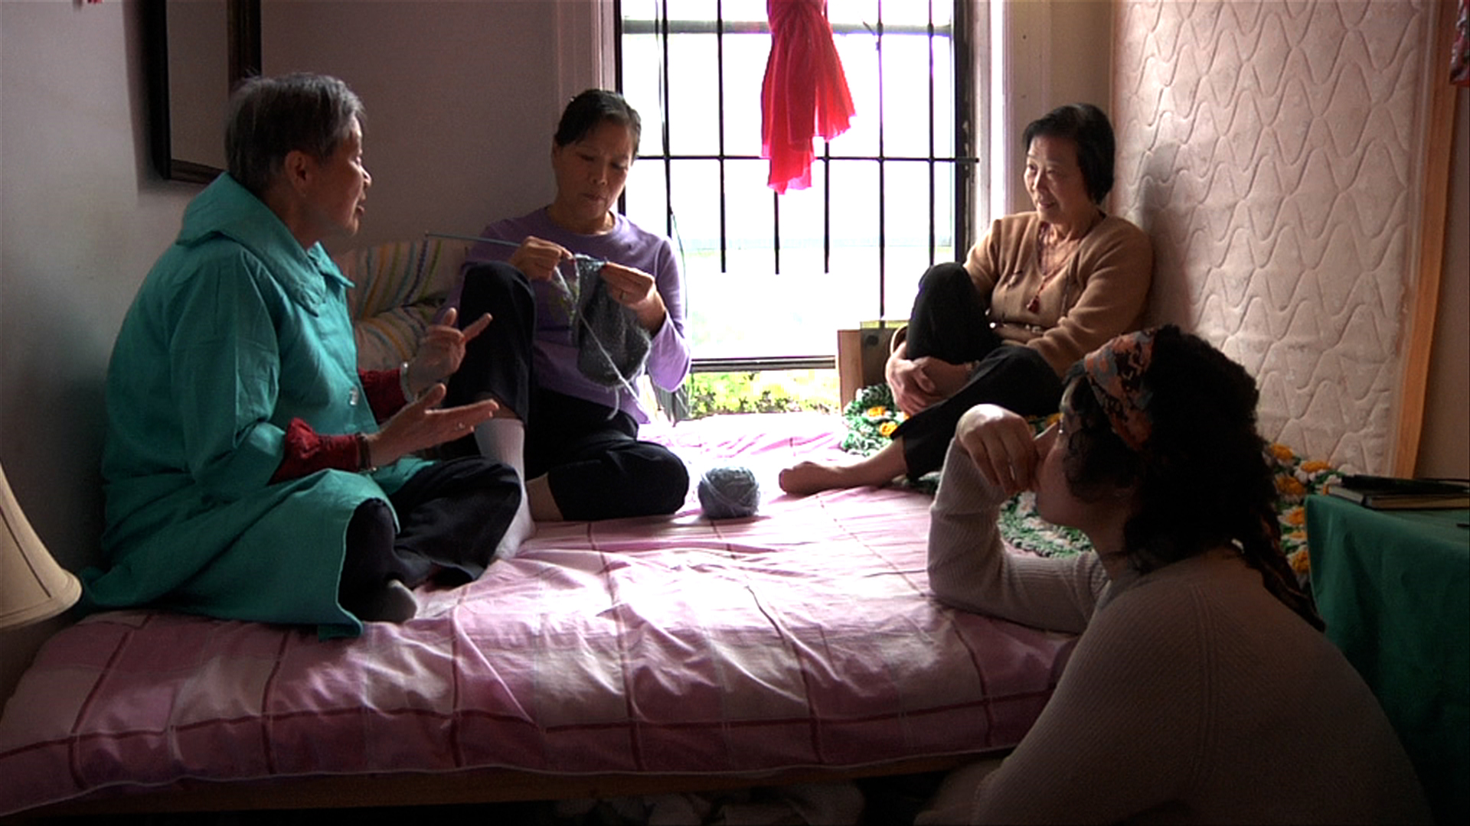

From left: Sheut Hing Lee, Linda Chan, Ellen Ho, and Veraalba Santa

From left: Kam Yin Tsui & Yun Xiu Huang

From left: Kam Tin Tsui & Yun Xiu Huang

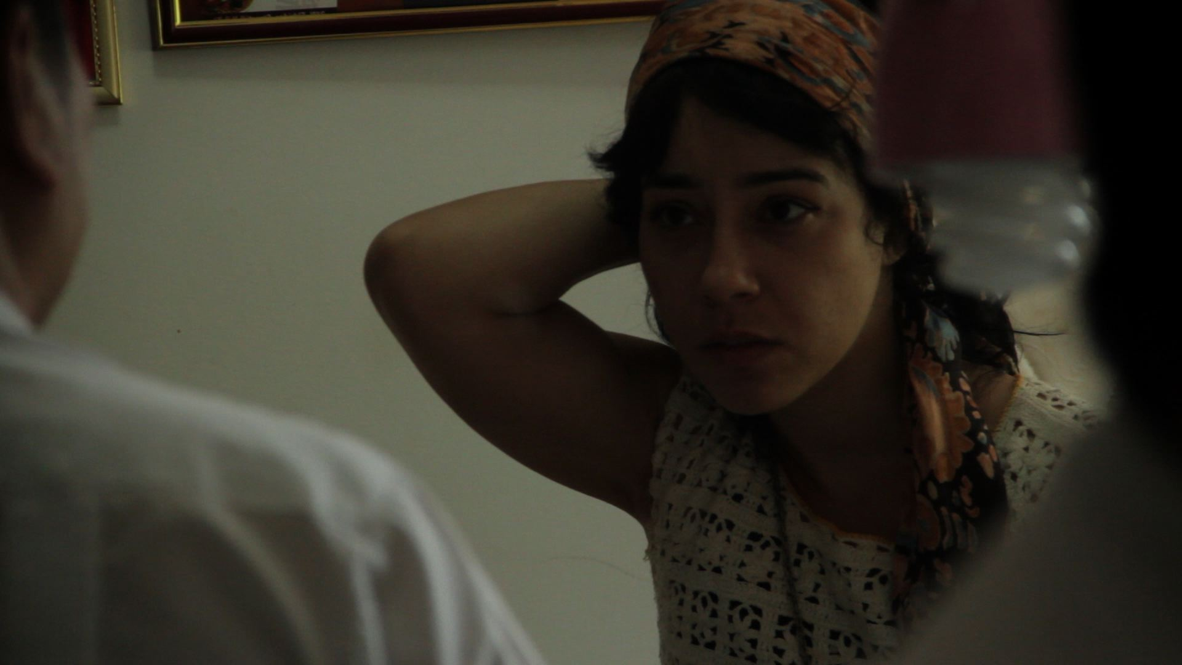

Lourdes (Veraalba Santa) talks to Yun Xiu Huang in Your Day is My Night

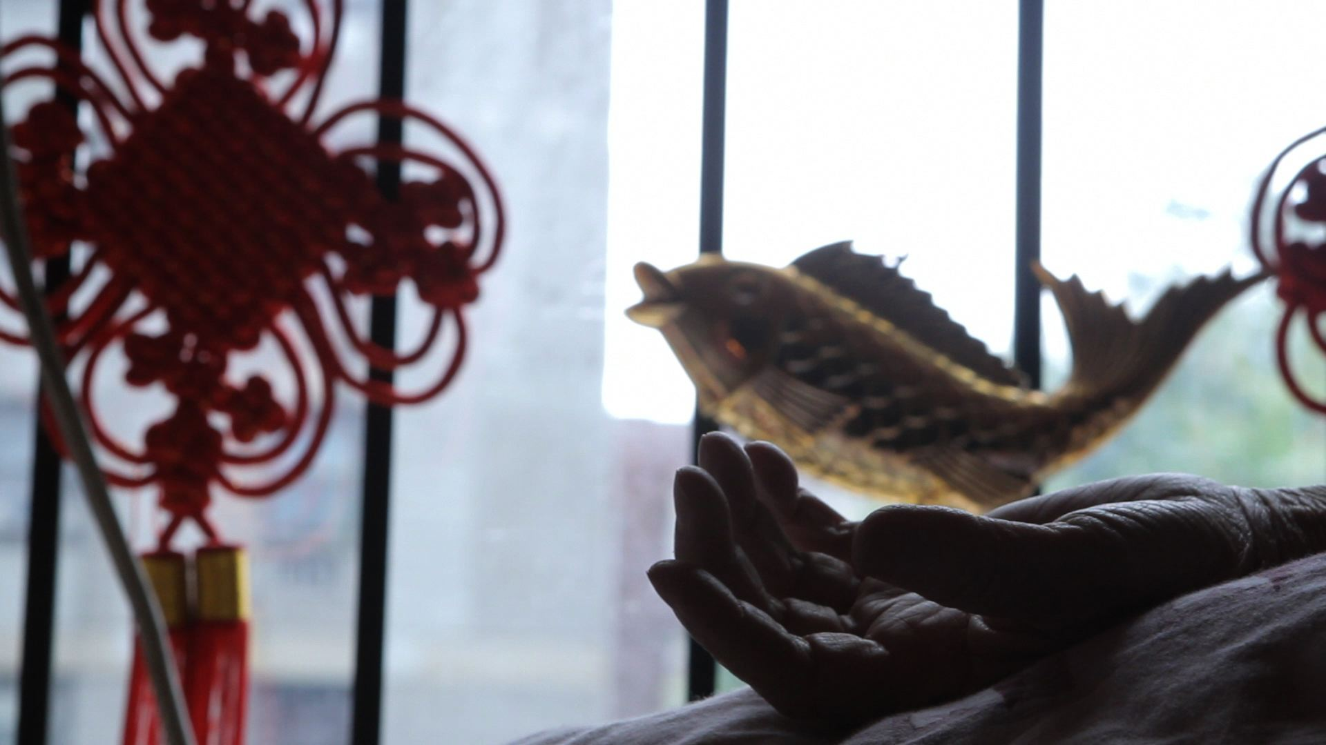

Still from Your Day is My Night

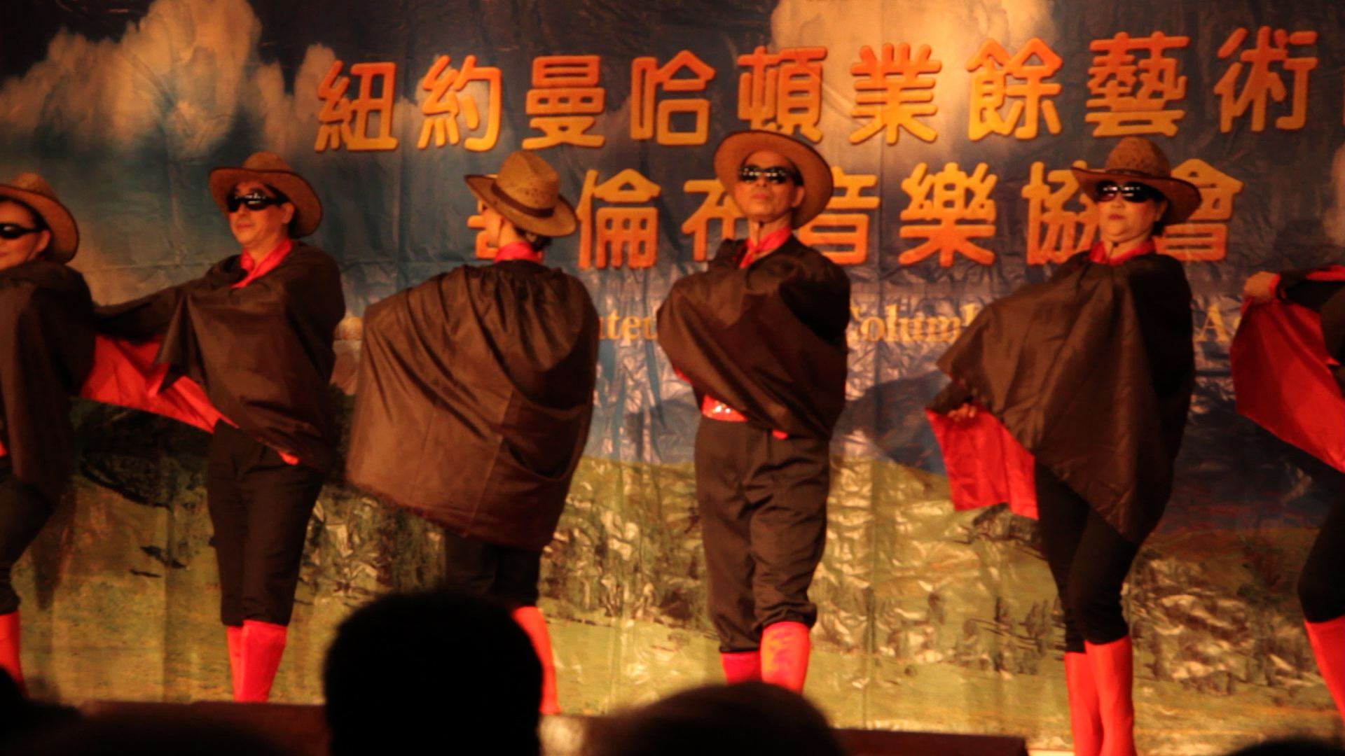

Still from Your Day is My Night

